Arcade Controller

Project Proposal

By Fenway Powers and Griffin Mandelbaum

April 8th 2021

**Abstract:**

The proposed project is an ATMega32u4 microcontroller based arcade style controller. The microcontroller will have 12 buttons hooked up to it, allowing it to play not only retro games, but also more modern games. The system is designed to be recognized as a Generic Input Controller, which allows it to be used on modern computers, including systems like Windows 10 PCs, Raspberry Pis, Macs, as well as Linux machines. A raspberry pi will be used in conjunction with the controller during the science symposium showcase. The estimated material cost is $57.97+tax, which will be funded by the Millbrook School Engineering Department. Final testing of the controller will be conducted during the spring semester of the 2020-2021 academic year.

**Introduction:**

There are a variety of arcade games that cannot be properly enjoyed on current gaming hardware. Games like pacman, space invaders, and other games lack the essential feel of arcade buttons on this more modern hardware. Retro games can be accessed and played on the raspberry pi for example, but there is no way to retain the original arcade feel without a bigger arcade-style controller.

In addition to retaining the feel of an arcade, the controller will also aim to be incredibly good at playing 2D games in general. Good D-pads (Directional Pads) on regular controllers are hard to come by, and this controller will aim to be better than even good D-pads at controlling 2D games.

**Proposed Solution:**

The proposed solution is to create an arcade controller while still being lightweight and portable. The case will be 3d printed into multiple different parts that connect so that the interior hardware can be accessed manually. The buttons will be removable in case of maintenance, but still firm in place.

There will be 12 buttons all with unique abilities, 4 will be directional, 2 for start and select, and 6 for action buttons in the game. A prototype will be made and tested before the unit is put into the final case.

The final part will be the artistic design of the system itself, the direction buttons will be painted with arrows and the box for the console itself will be hand painted to give the design a flashy look.

The choice to use an arduino leonardo as opposed to the popular arduino uno is because the leonardo is equipped with the ATMega32u4 chip, which allows it to be HID-compliant. This means a computer will recognize it as an input device, such as a keyboard, mouse, or even a controller.

An Arduino Code Library made by Matthew Heironimus will be utilized when coding the controller. For testing and showcasing, the controller will be hooked up to a raspberry pi via usb. The pi will be running an operating system such as bacotera linux, which has built in emulators and controller interface.

All of the games used in the showcase will be either legally obtained ROMs (such as through Sega Genesis Classics on Steam), or they will be free, open source homebrew games.

**Block Diagram:**

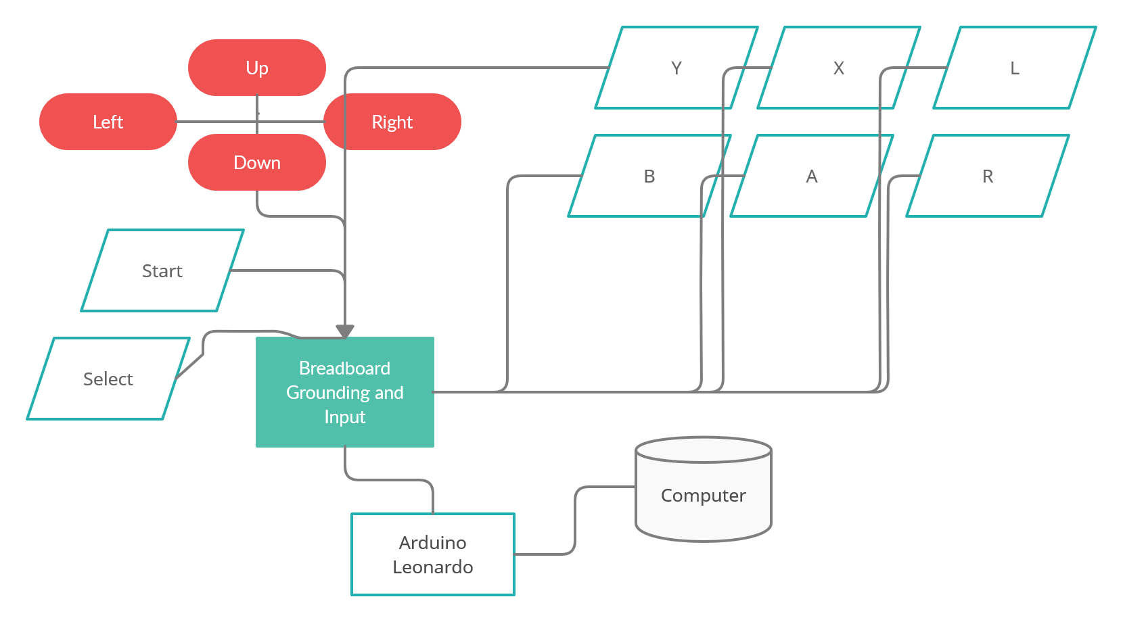

**Main Components:**

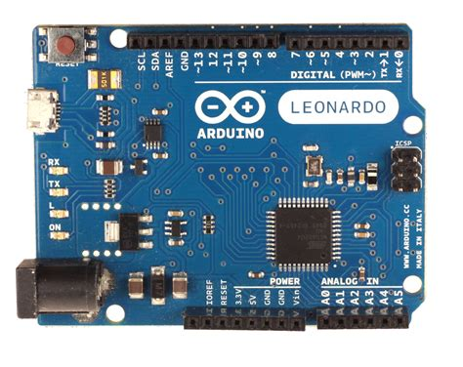Arduino Leonardo microcontroller (ATMega32u4)

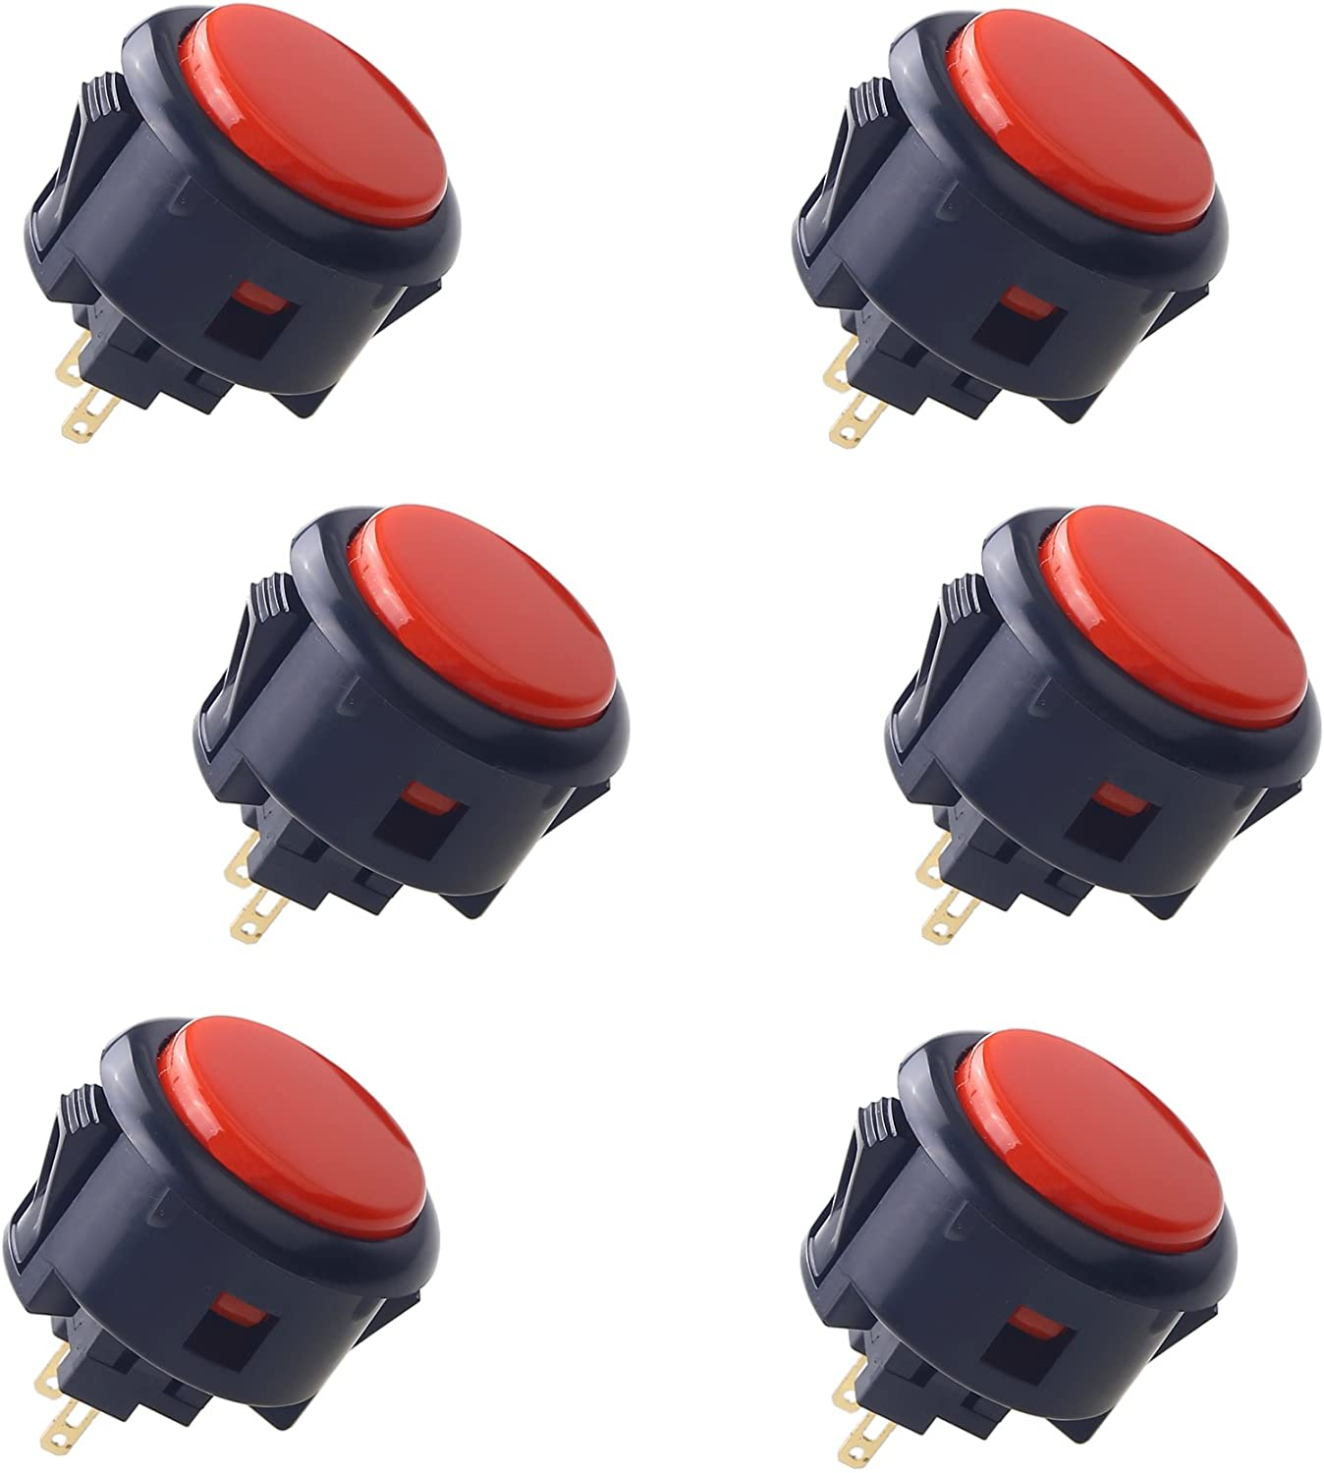Sanwa 6 pcs OBSF-30 30mm Buttons (x2)

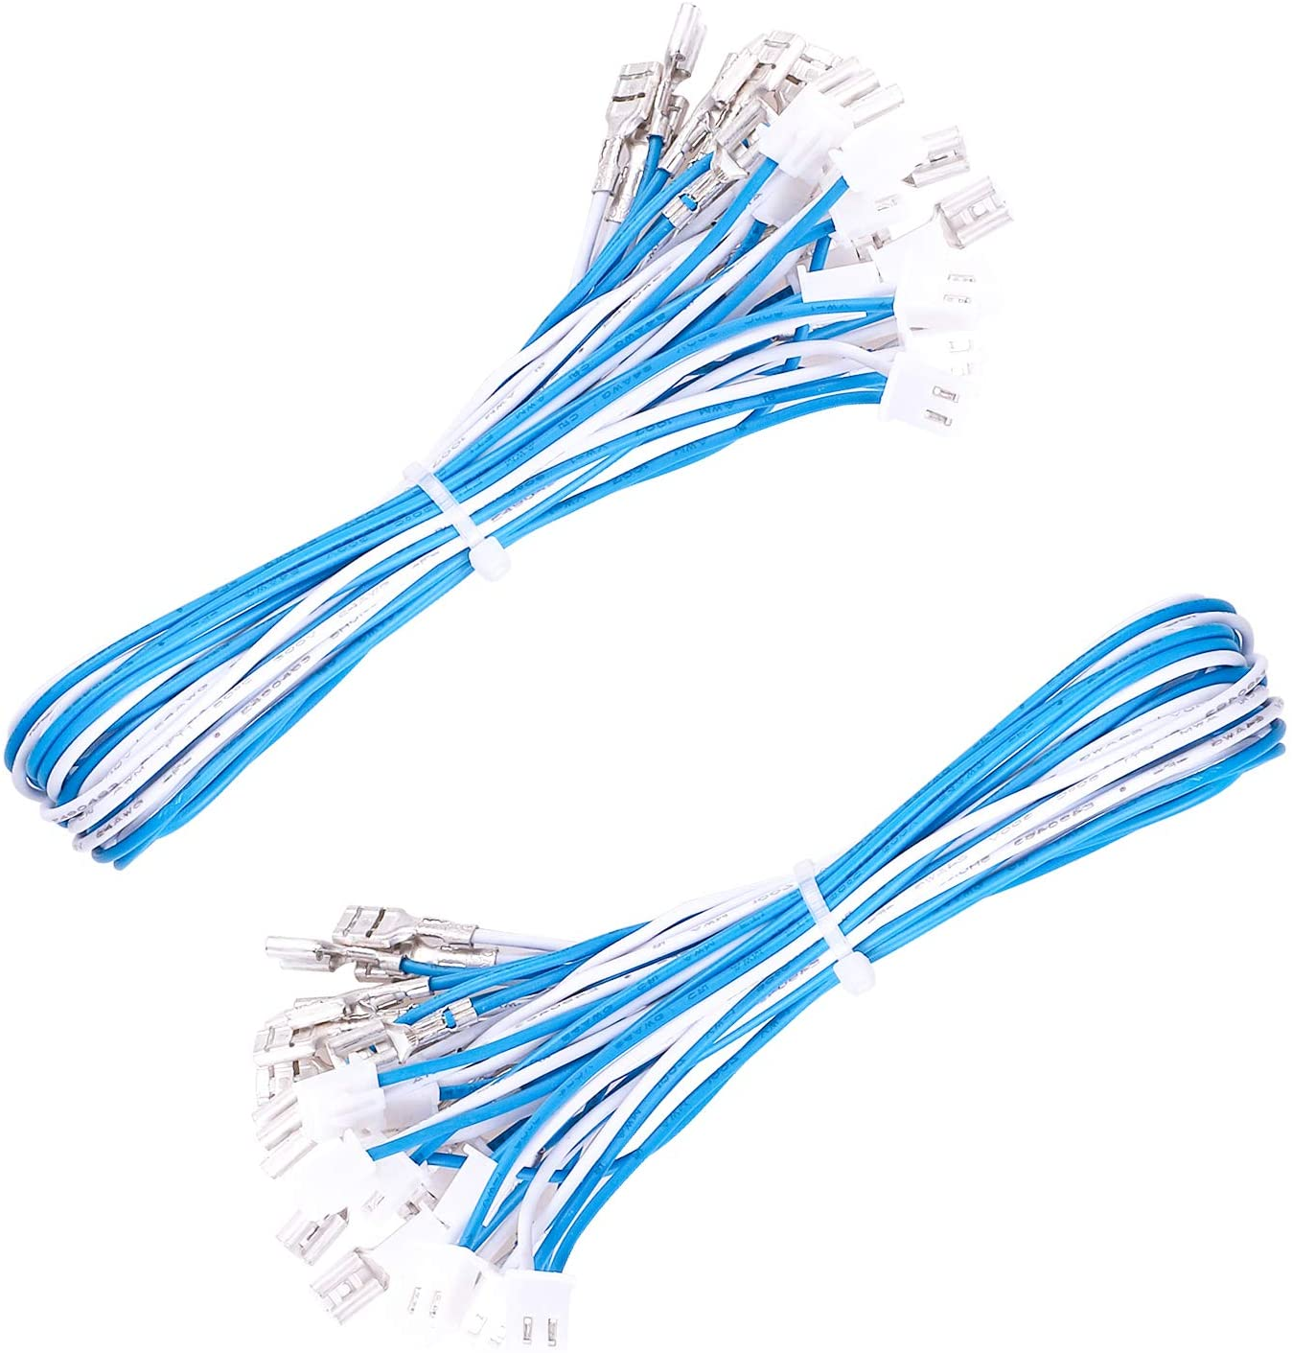20 pcs USB Encoder Wire Harness

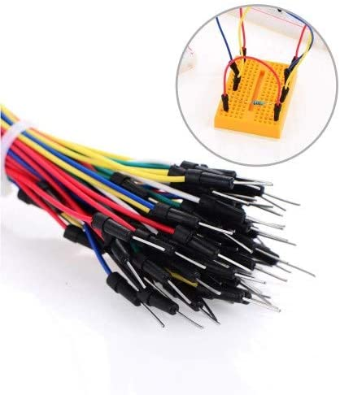Solderless Flexible Breadboard Wires + Breadboard

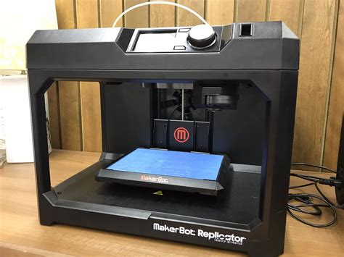3D Printer (At School)

**Personnel:**

Oversight and the direct wiring, alongside coding will be done by Fenway Powers. Mr. Powers has experience not only coding in languages C, Python, and Arduino C, he understands a variety of different gaming hardware and will be able to see any flaws in the build itself. He is the one who owns the raspberry pi that will be used in the project.

The visual designing, partial coding, and outside design will be done by Griffin Mandelbaum. He is experienced in coding in the languages of C, Python, and Arduino C, he also has taken a multitude of coding classes and will be able to create a box for the console in not only which everything will fit, but also be readily accessible. Alongside this he can design the controls and make sure that every piece of the build is not only stable but visually pleasing.

**Cost Estimate:**

|  |  |  |  |
| --- | --- | --- | --- |
| Item | Quantity | Unit Cost | Item Subtotal |
| Arduino Leonardo | 1 | 9.99 | 9.99+tax |
| Sanwa 6 pcs OBSF-30 30mm Buttons | 2 | 15.75 | 31.50+tax |
| Solderless Flexible Breadboard Jumper Wires | 1 | 6.49 | 6.49+tax |
| 20 pcs USB Encoder Wire Harness | 1 | 9.99 | 9.99+tax |
|  |  | Total: | 57.97+tax |

**Project Timeline:**

|  |  |  |  |
| --- | --- | --- | --- |
| **Task** | **Date** | **End Date** | **Personnel** |
| Coding + Prototype | 4/15/21 | 4/21/21 | FP/GM |
| Case Design + Print | 4/22/21 | 5/7/21 | FP/GM |
| Fitting, testing, and painting | 5/8/21 | Whenever the project is due | FP/GM |

**Safety:**

The project managers will make sure that no wires are dangerously exposed, by properly testing the wires on the arduino prior to putting it into the case. Additionally, the 3D printer will be prepped before turned on making sure everything is ready and clearing off the surface area. After clearing it off we will make sure that there is a way to get cool air into the room to make sure the temperature does not reach dangerous levels. Any tools used like knives or any other hand held tool will be the own person's responsibility to make sure they use it properly.

**References:**

<https://www.instructables.com/Create-a-Joystick-Using-the-Arduino-Joystick-Libra/>

<https://youtu.be/6MeaotesUWY>